**DEPARTMENT OF COMPUTER ENGINEERING**

**Punjabi University, Patiala-147002**

**Punjab (India)**

****

**PROJECT REPORT**

Of

**Six Weeks Industrial Training**

On

**“Aadhar as Social Security Number”**

At

**TCS ion**

**Patiala**

**Submitted By-**

**Jaskaran Singh**

**Roll No. 11501050**

**3CE-2**

**Semester-5**

****

##### D:\New Doc 2017-10-24_1.jpg

##### PREFACE

##### This work has been done as a part of summer training. The purpose of the training was to make the programming skills strong in Core Java as well as Advance Java.

##### The students are provided with the opportunity to study the latest technical trends. The things student learn during the summer training will certainly help their potential and technical skills.

##### As a part of our summer training I undertook a project “Aadhar As Social Security Number” at TCS ION, Patiala. I also came to know what sorts of problems occur in the project development and how they can be solved.

##### At last with our all gratitude I would like to thank our entire colleagues and project guide for their help in the development of the project.

##### ACKNOWLEDGEMENT

##### I take this opportunity to express our profound gratitude and deep regards to our Respected Sir Sharnjit for his exemplary guidance, monitoring and constant encouragement throughout the course of this training. The blessing, help and guidance given by his time to time shall carry us long way in the journey of life on which we are about to embark.

##### I am obliged to staff members of TCS ION, Patiala for the valuable information provided by them in their respective fields. I am grateful for their cooperation during the period of our training.

##### Lastly, I thank almighty, our parents, family and friends for their constant encouragement without which this assignment would not be possible.

Jaskaran Singh

## Table of Contents

|  |  |  |
| --- | --- | --- |
| SR. No. | Description | Page No. |
| 1. | Certificate | 2. |
| 2. | Preface | 4. |
| 3. | Acknowledgement | 5. |
| 4. | Company Profile | 7. |
| 5. | Technology Used | 8. |
| 6. | Project | 16. |
| 7. | Screenshots | 21. |
| 8. | Bibliography | 37. |

##### Company Profile

##### Capture

# iON is a strategic unit of Tata Consultancy Services focused on Manufacturing Industries (SMB), Educational Institutions and Examination Boards. TCS iON provides technology by means of a unique IT-as-a-Service model, offering end-to-end business solutions. It caters to the needs of multiple industry segments, through innovative, easy-to-use, secured, integrated, hosted solutions in a build-as-you-grow, pay-as-you-use business model. TCS iON serves its clients with the help of best practices gained through TCS' global experience, domestic market reach, skills, and delivery capabilities. iON's Cloud Based Solution is highly modular, scalable and configurable giving businesses and educational institutions the benefits of increased efficiencies, faster go to market, predictability of technology as well as spend and better business results.

## Integrated solutions

* Increased Agility
* Personalized Solutions
* Auto Upgrades
* Enhanced Business Continuity

##### Introduction to Technology Used

##### JAVA

Java technology is both a programming language as well as a platform. Java was developed by Patrick Naughton and James Gosling at SUN Microsystems. The Java programming language is a high level object-oriented language that has a particular syntax and style.

Java compiler compiles the source code to Byte Code that can be executed on different platforms using JVM (Java Virtual Machine). The Byte Code is same, no matter what hardware or OS the program is running under.

Components of JDK:

Javac - Compiler

Java - Interpreter

JDB - Java Debugger

Jar - A tool to create and export Java archive.

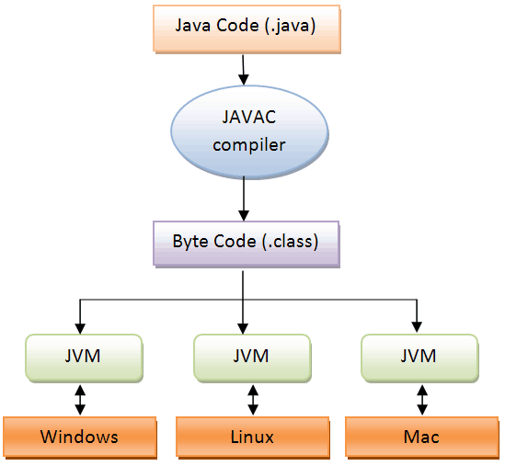

##### The Java Programming Language

The Java programming language is a high-level language that can be characterized by all of the following buzzwords:

|  |  |
| --- | --- |
| * Architecture neutral * Portable * High performance * Robust * Secure | * Simple * Object oriented * Distributed * Multithreaded * Dynamic |

In the Java programming language, all source code is first written in plain text files ending with the .java extension. Those source files are then compiled into .class files by the javaccompiler. A .class file does not contain code that is native to your processor; it instead contains bytecodes — the machine language of the Java Virtual Machine[1](https://docs.oracle.com/javase/tutorial/getStarted/intro/definition.html#FOOT) (Java VM). The javalauncher tool then runs your application with an instance of the Java Virtual Machine.

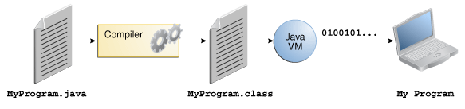

An overview of the software development process.

Because the Java VM is available on many different operating systems, the same .class files are capable of running on Microsoft Windows, the Solaris™ Operating System (Solaris OS), Linux, or Mac OS. This includes various tasks such as finding performance bottlenecks and recompiling (to native code) frequently used sections of code.

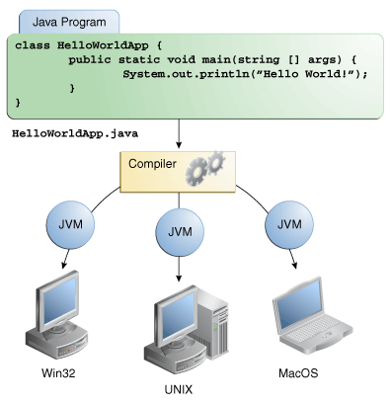

Through the Java VM, the same application is capable of running on multiple platforms.

##### The Java Platform

A platform is the hardware or software environment in which a program runs. We've already mentioned some of the most popular platforms like Microsoft Windows, Linux, Solaris OS, and Mac OS. Most platforms can be described as a combination of the operating system and underlying hardware. The Java platform differs from most other platforms in that it's a software-only platform that runs on top of other hardware-based platforms.

The Java platform has two components:

* The Java Virtual Machine
* The Java Application Programming Interface (API)

You've already been introduced to the Java Virtual Machine; it's the base for the Java platform and is ported onto various hardware-based platforms.

The API is a large collection of ready-made software components that provide many useful capabilities. It is grouped into libraries of related classes and interfaces; these libraries are known aspackages.

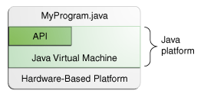

The API and Java Virtual Machine insulate the program from the underlying hardware.

As a platform-independent environment, the Java platform can be a bit slower than native code. However, advances in compiler and virtual machine technologies are bringing performance close to that of native code without threatening portability.

##### MYSQL

MySQL (“My S-Q-L”, officially, but also called “My Sequel”) is (as of July 2013) the world’s second most widely used open-source relational database management system (RDBMS). It is named after co-founder Michael Widenius daughter, My. The SQL phrase stands for Structured Query Language.

The MySQL development project has made its source code available under the terms of the GNU General Public License, as well as under a variety of proprietary agreements. MySQL was owned and sponsored by a single for-profit firm, the Swedish company MySQL AB, now owned by Oracle Corporation

.MySQL is a popular choice of database for use in web applications, and is a central component of the widely used LAMP open source web application software stack (and other ‘AMP’ stacks). LAMP is an acronym for “Linux, Apache, MySQL, Perl/PHP/Python.” Free-software-open source projects that require a full-featured database management system often use MySQL. For commercial use, several paid editions are available, and offer additional functionality. Applications which use MySQL databases

MySQL, the most popular Open Source SQL database management system, is developed, distributed, and supported by Oracle Corporation..

* **MySQL is a database management system.**

A database is a structured collection of data. It may be anything from a simple shopping list to a picture gallery or the vast amounts of information in a corporate network. To add, access, and process data stored in a computer database, you need a database management system such as MySQL Server. Since computers are very good at handling large amounts of data, database management systems play a central role in computing, as standalone utilities, or as parts of other applications.

* **MySQL databases are relational.**

A relational database stores data in separate tables rather than putting all the data in one big storeroom. The database structures are organized into physical files optimized for speed. The logical model, with objects such as databases, tables, views, rows, and columns, offers a flexible programming environment. You set up rules governing the relationships between different data fields, such as one-to-one, one-to-many, unique, required or optional, and “pointers” between different tables. The database enforces these rules, so that with a well-designed database, your application never sees inconsistent, duplicate, orphan, out-of-date, or missing data.

The SQL part of “MySQL” stands for “Structured Query Language”. SQL is the most common standardized language used to access databases. Depending on your programming environment, you might enter SQL directly (for example, to generate reports), embed SQL statements into code written in another language, or use a language-specific API that hides the SQL syntax.

SQL is defined by the ANSI/ISO SQL Standard. The SQL standard has been evolving since 1986 and several versions exist. In this manual, “SQL-92” refers to the standard released in 1992, “SQL:1999” refers to the standard released in 1999, and “SQL:2003” refers to the current version of the standard. We use the phrase “the SQL standard” to mean the current version of the SQL Standard at any time.

* **MySQL software is Open Source.**

Open Source means that it is possible for anyone to use and modify the software. Anybody can download the MySQL software from the Internet and use it without paying anything. If you wish, you may study the source code and change it to suit your needs. If you feel uncomfortable with the GPL or need to embed MySQL code into a commercial application, you can buy a commercially licensed version from us.

* **The MySQL Database Server is very fast, reliable, scalable, and easy to use.**

If that is what you are looking for, you should give it a try. MySQL Server can run comfortably on a desktop or laptop, alongside your other applications, web servers, and so on, requiring little or no attention. If you dedicate an entire machine to MySQL, you can adjust the settings to take advantage of all the memory, CPU power, and I/O capacity available. MySQL can also scale up to clusters of machines, networked together.

You can find a performance comparison of MySQL Server with other database managers on our benchmark page.

MySQL Server was originally developed to handle large databases much faster than existing solutions and has been successfully used in highly demanding production environments for several years. Although under constant development, MySQL Server today offers a rich and useful set of functions. Its connectivity, speed, and security make MySQL Server highly suited for accessing databases on the Internet.

* **MySQL Server works in client/server or embedded systems.**

The MySQL Database Software is a client/server system that consists of a multi-threaded SQL server that supports different backends, several different client programs and libraries, administrative tools, and a wide range of application programming interfaces (APIs).

We also provide MySQL Server as an embedded multi-threaded library that you can link into your application to get a smaller, faster, easier-to-manage standalone product.

* **A large amount of contributed MySQL software is available.**

MySQL Server has a practical set of features developed in close cooperation with our users. It is very likely that your favorite application or language supports the MySQL Database Server

##### Software Requirements:

* .**NET Framework 3.5**
* **NetBeans IDE**
* **MySQL/Oracle**

##### Hardware Requirements:

**Processor: Preferably 1.0 GHz or Greater.**

**RAM : 512 MB or Greater.**

##### PROJECT

THE EYE is an application which basically deals in restricting the movement of defaulters around the world. Any law agency which finds a particular person defaulter can restrict his movement between cities, states or even countries with the help of our product.

THE EYE is a project which aims in developing a link between the aadhar number ,passport number and driving license number of an individual and hence maintaining and securing the database so developed .This project basically tries to use Aadhar as the only identification number similar to the Social Security Number one have in foreign countries . It has also a facility where admin after logging in their accounts can check real time status for an individual and hence the person can be easily identified if he is trying to flee from the region. The law agencies after logging into their account can view and/or update the status of the person.

Overall this project of ours is being developed to help put the defaulters behind the bars and furthermore to help the agencies capture the suspects more easily.

##### PRODUCT DESCRIPTION:

THE EYE is a project which aims in developing a link between the aadhar number ,passport number and driving license number of an individual and hence maintaining and securing the database so developed .This project basically tries to use Aadhar as the only identification number similar to the Social Security Number one have in foreign countries .

**PROBLEM STATEMENT:**

The problem occurred before having computerized system includes:

* **Identity Theft:**

Usually the clever ones were able to copy the aadhar data and may even misuse it like or sim cards etc.

* **Fake entries:**

Before computerised entries fake entries or duplicate entries or wrong entries were at huge risk.

* **Difficult to search record** :

When there is no computerized system there is always a difficulty in knowing the original status of a person like whether a warrant is issued or not against him that too in real time.

* **Defaulters fleeing even from countries:**

Earlier the defaulters were easily able to flee from the region where they were in a danger.

* **Difficulty in grabbing the guilty:**

As the defaulters usually flee from scene and hence it was a bit difficult for law agencies to grab hold of them.

##### SYSTEM OBJECTIVES

**Improvement in control and performance**

The system is developed to cope up with the current issues and faults in the chainholding of guilty ones .The system can add user, validate user and that too in real time.

**Saves workforce**

After computerized system is implemented less human force will be required to maintain the check on the guilty or defaulters.

**Save time**

The agencies are able to search record by using few clicks of mouse and few search keywords thus saving their valuable time.

***Features***

**ADMIN LOGIN**

Description of feature

This feature used by the admin to login into system. They are required to enter user name and password before they are allowed to enter the system .The username and password will be verified and if invalid name access is denied.

Functional requirements

-user id is provided when they register

-The system must only allow user with valid id and password to enter the system

-The system performs authorization process which decides what user level can acess to.

-The user must be able to logout after they finished using system.

**REGISTER NEW USER**

Description of feature

This feature can be performed by all users to register new user to create account.

Functional requirements

-System must be able to verify information

-System must be able to delete information if information is wrong

**REGISTER NEW ENTRY**

Description of feature

This feature allows to add new user via his aadhar no. to the database.

Functional requirements

-System must be able to verify information

**CHECK STATUS OF PERSON**

Description of feature

This feature is used to check the status of person .

Functional requirements

-System must be able to search in database.

-System must give the exact data in real time.

**UPDATE STATUS OF PERSON**

Description of feature

This feature is used to change information regarding a person record already saved in the database.

Functional requirement

-System must be able to search for a particular aadhar no., passport no. or driving licence no. in the database.

-System must provide the information on the person issued by the law agencies.

##### CODE FOR MODULES(NETBEANS)

* Change\_Password.java
* Login\_Page,java
* Login\_successful.java
* Master\_Login.java
* New\_Entry.java
* New\_User\_Entry.java
* Update\_Entry.java
* Check\_Status\_Of\_Person.java
* Update\_Status\_Of\_Person.java

##### Data Flow Diagram

Database

ADMIN Enter Username and Password Check Validity

Login Page

##### VARIOUS TABELS TO MAINTAIN INFORMATION

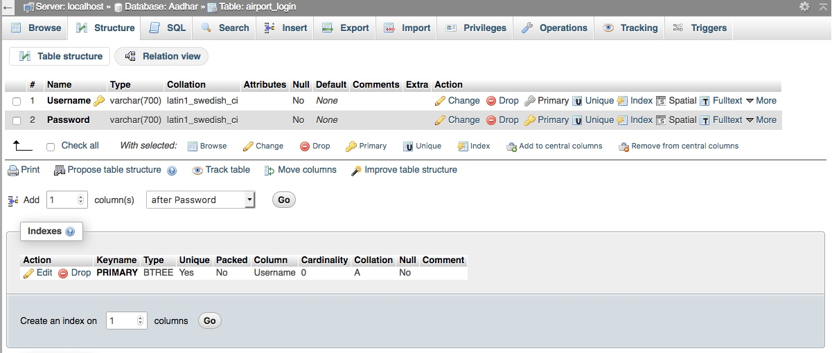

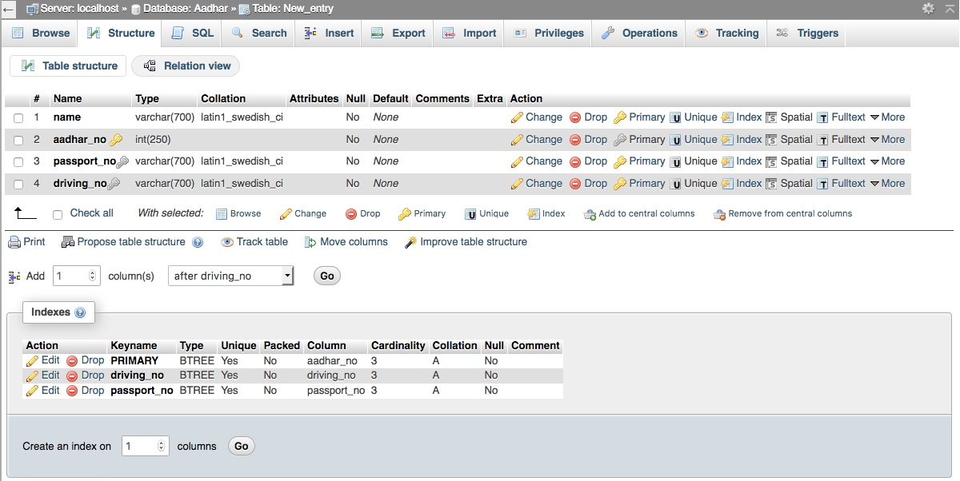

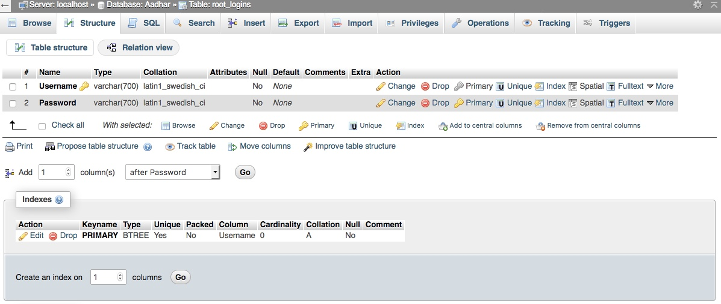

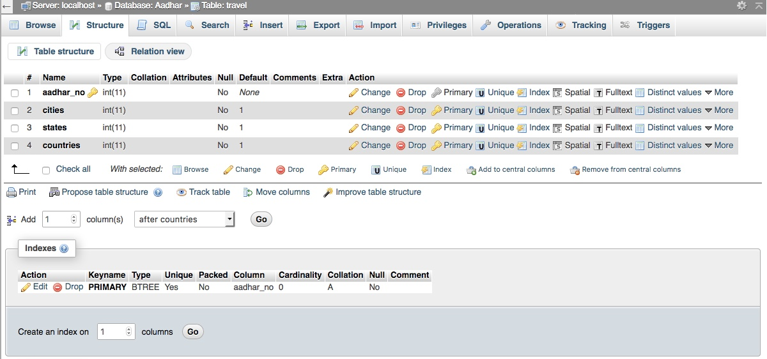

***APPLICATION SNAPSHOTS***

Login page

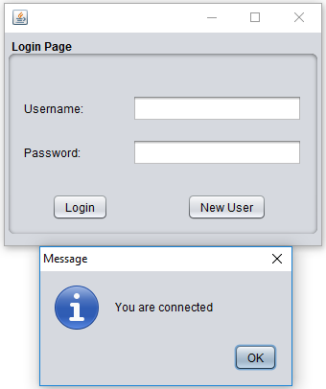

Master Password

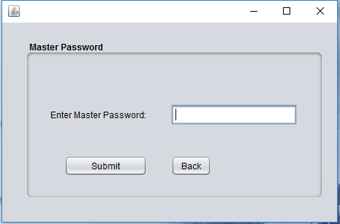

Login Successful

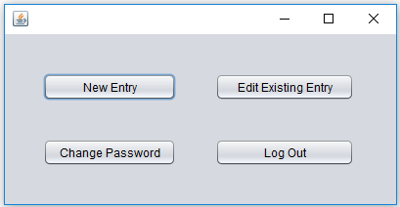

New User Entry

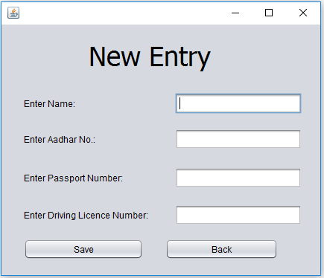

Update User Entry

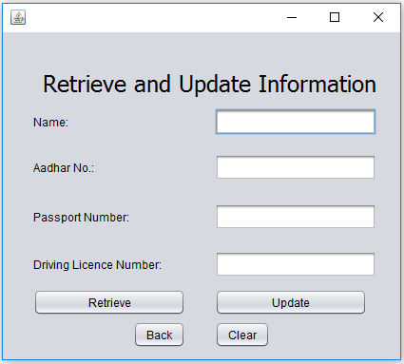

Change Password

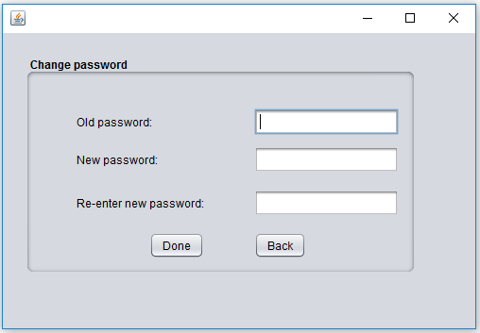

Login Successful

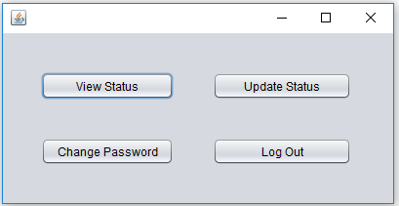

View Status

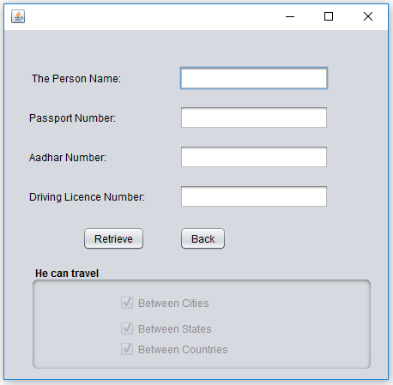

Update Status

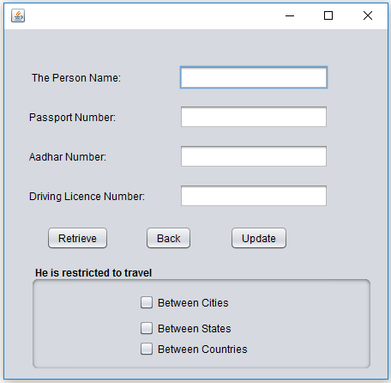

Our Website:

Homepage

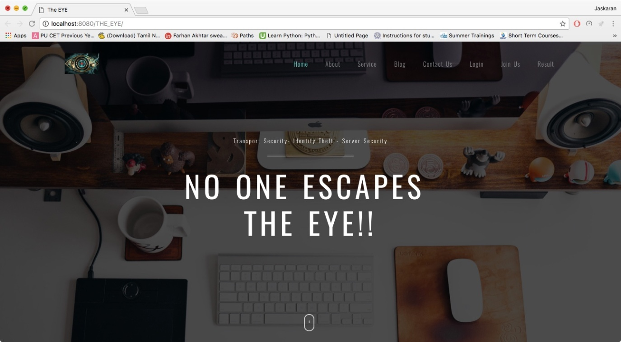

About Us:

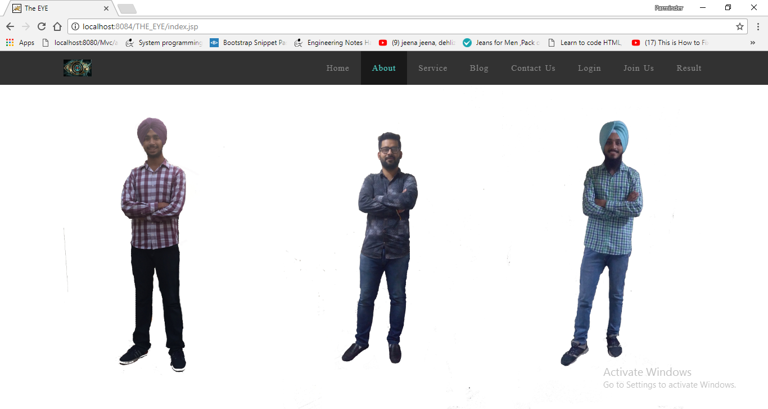

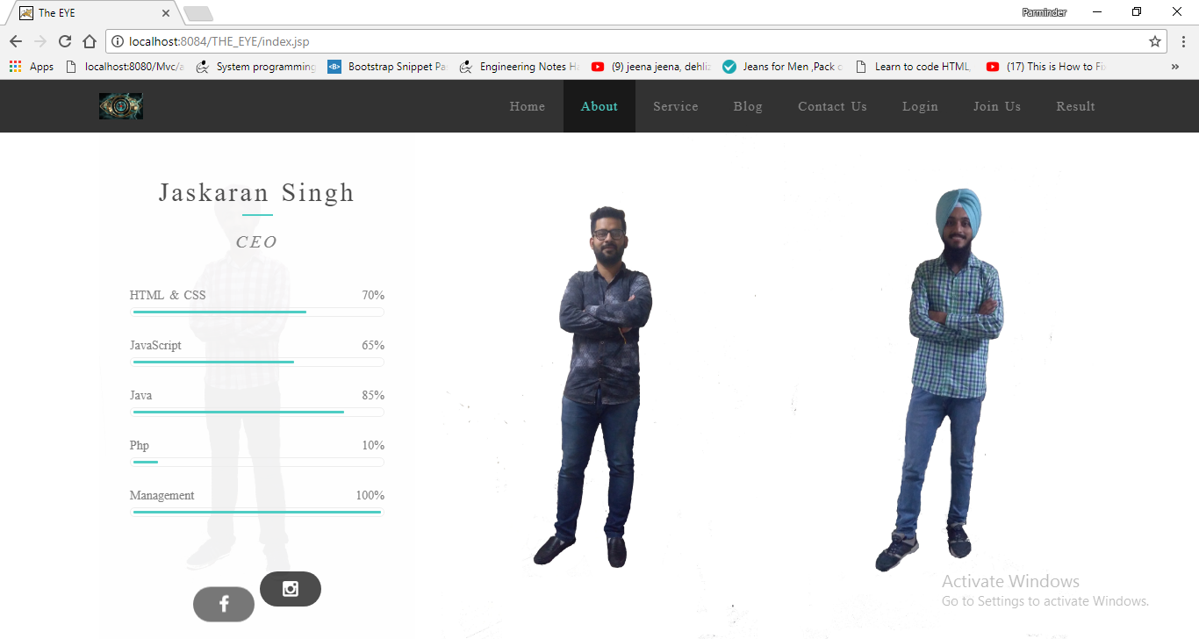

Services:

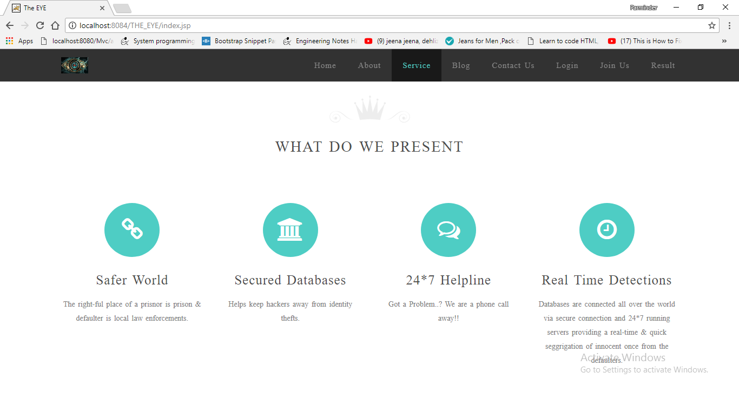

Our Clients:

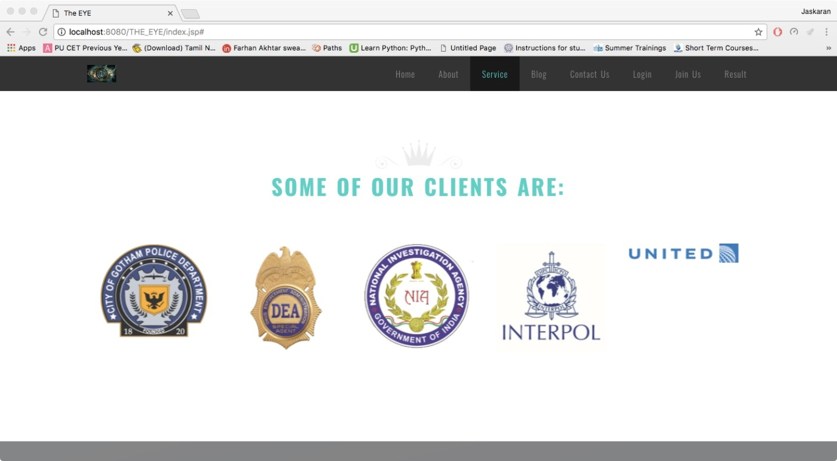

Blog:

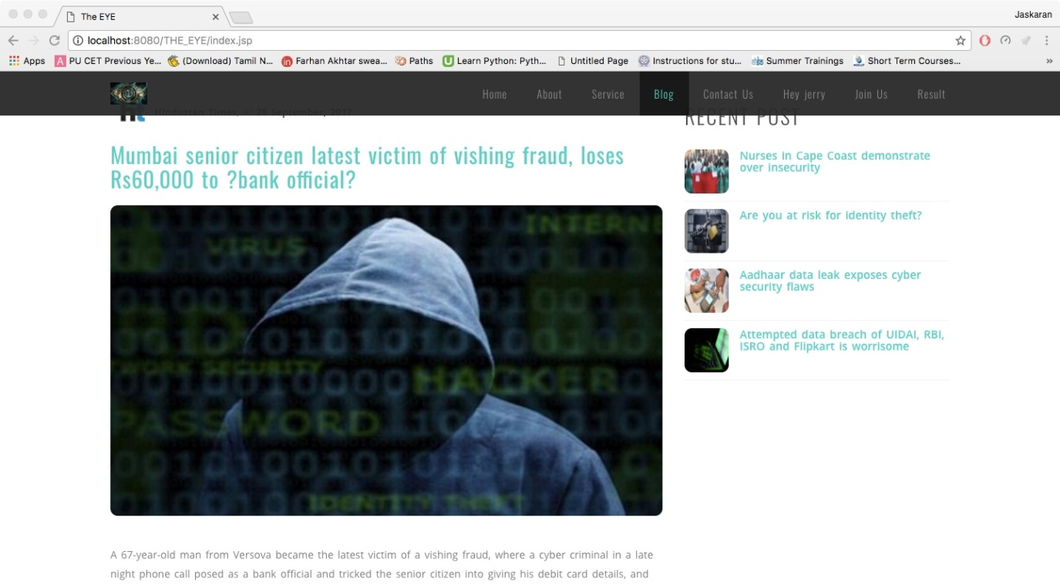

Contact Us:

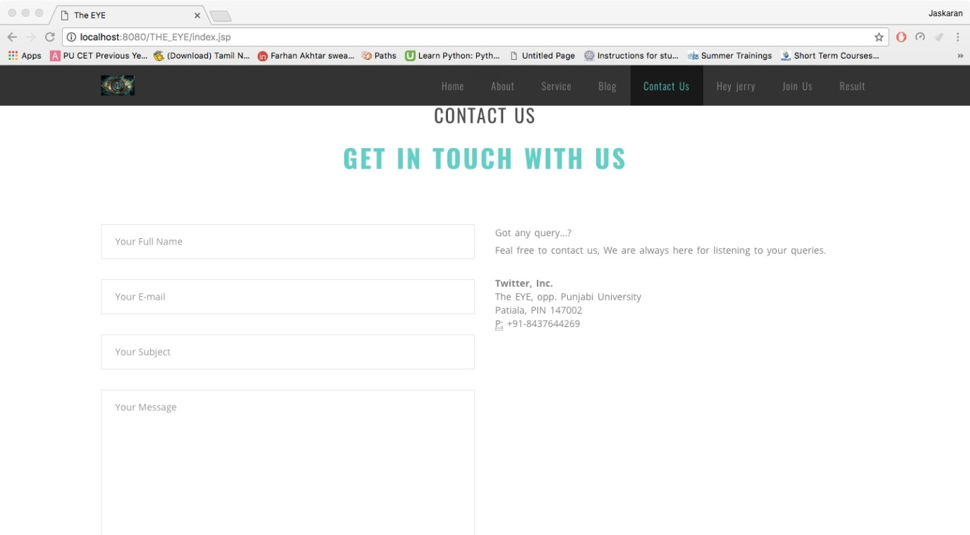

Some FAQ’s:

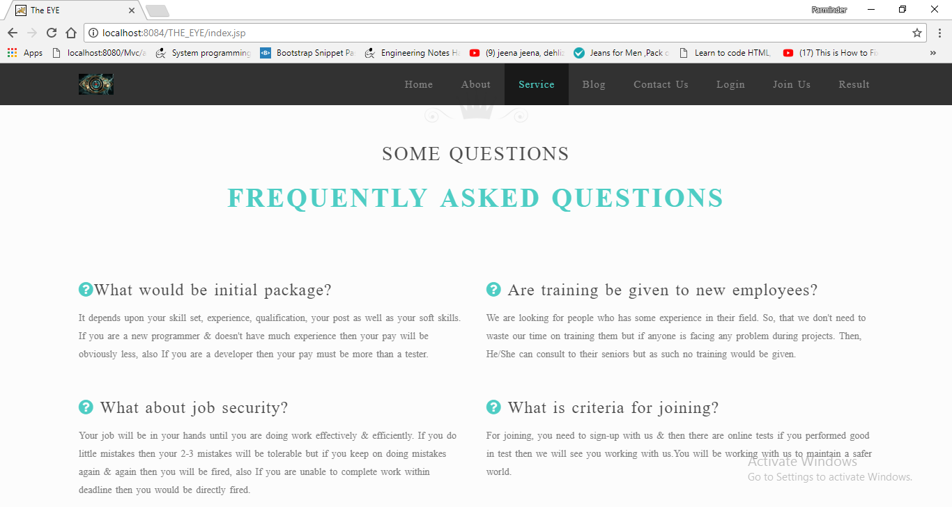

Login Page:

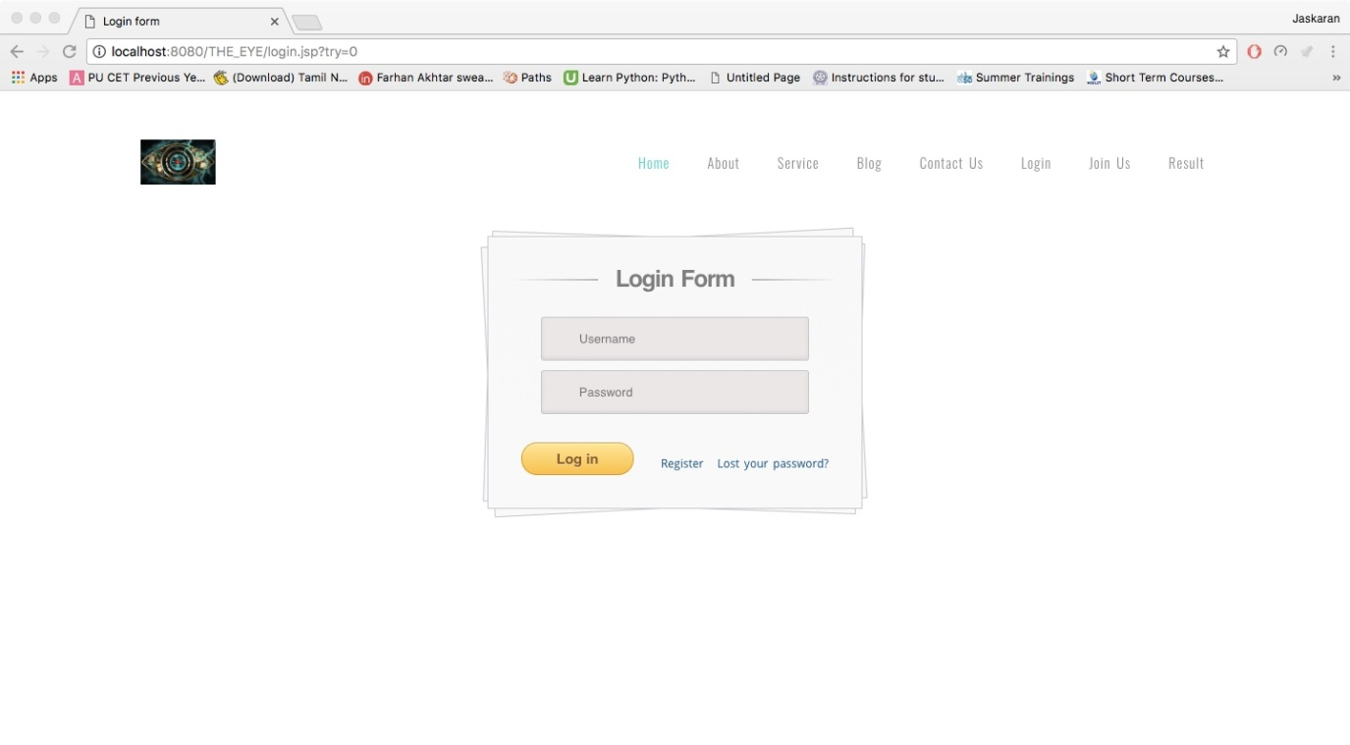

Join Us/Register:

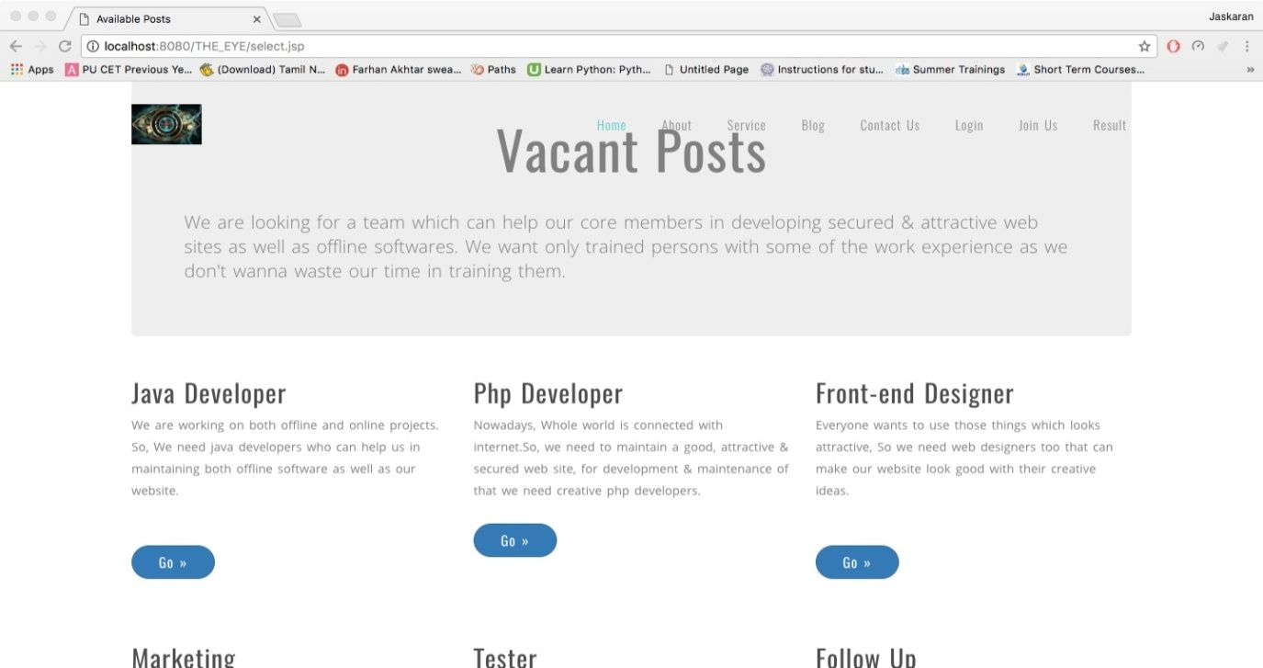

Sign-up Form:

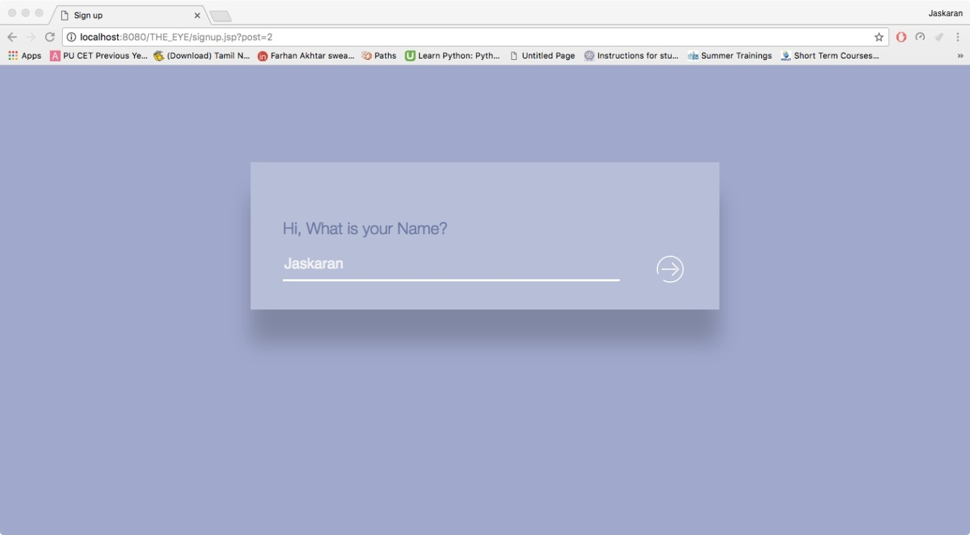

Forget Password:

Page-1:

***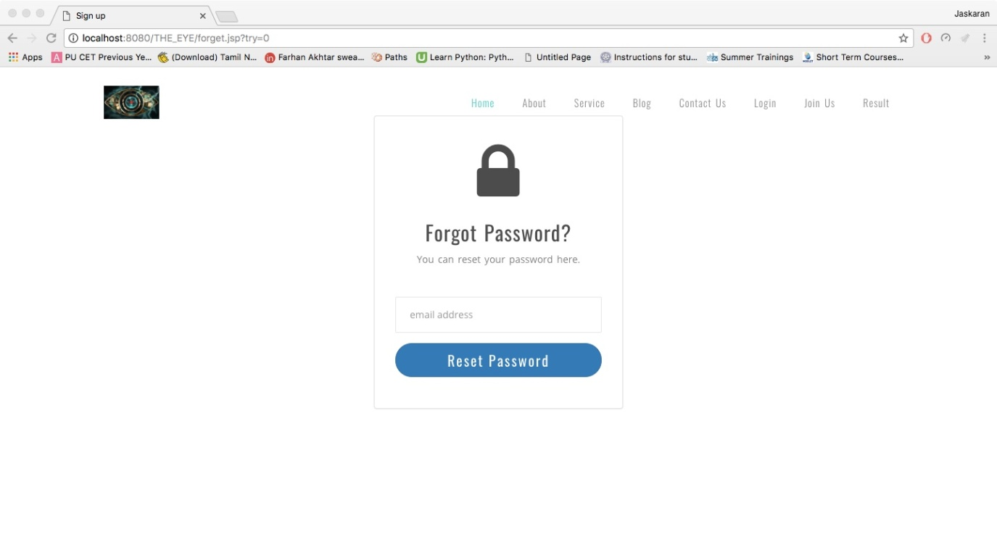***

Page-2:

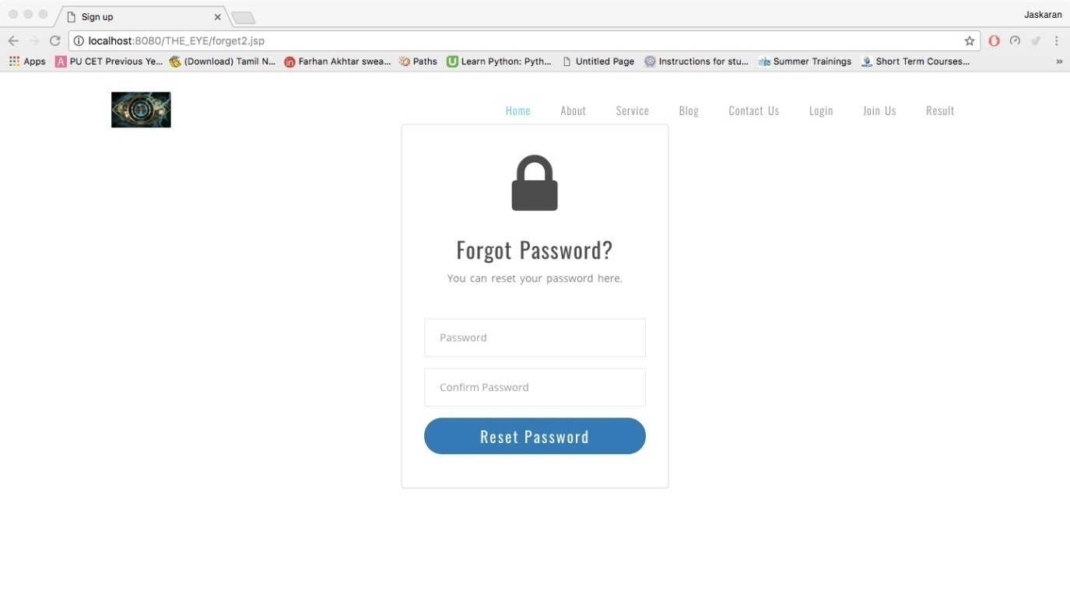

Profile:

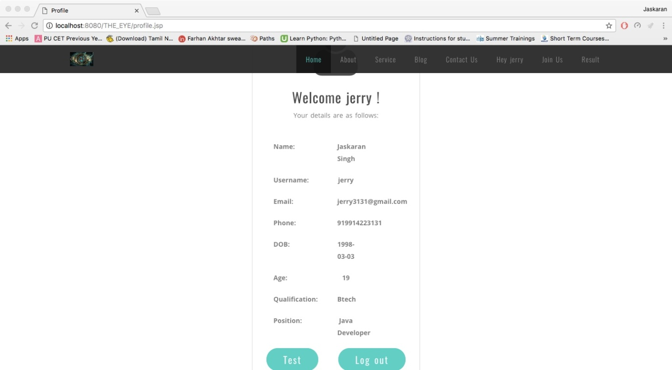

Test:

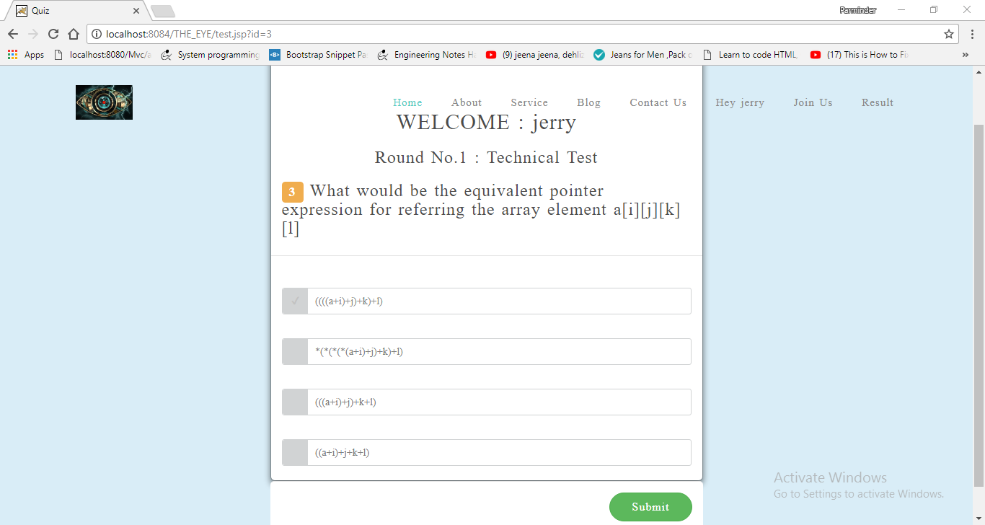

Result:

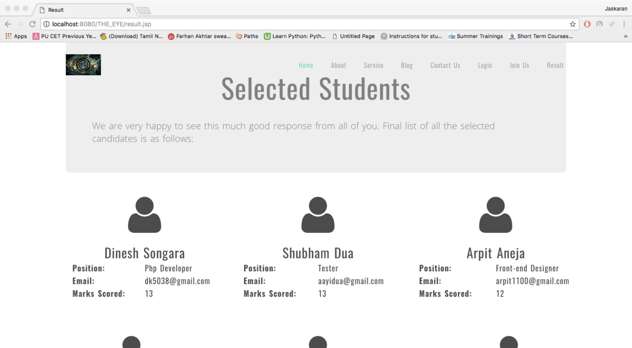

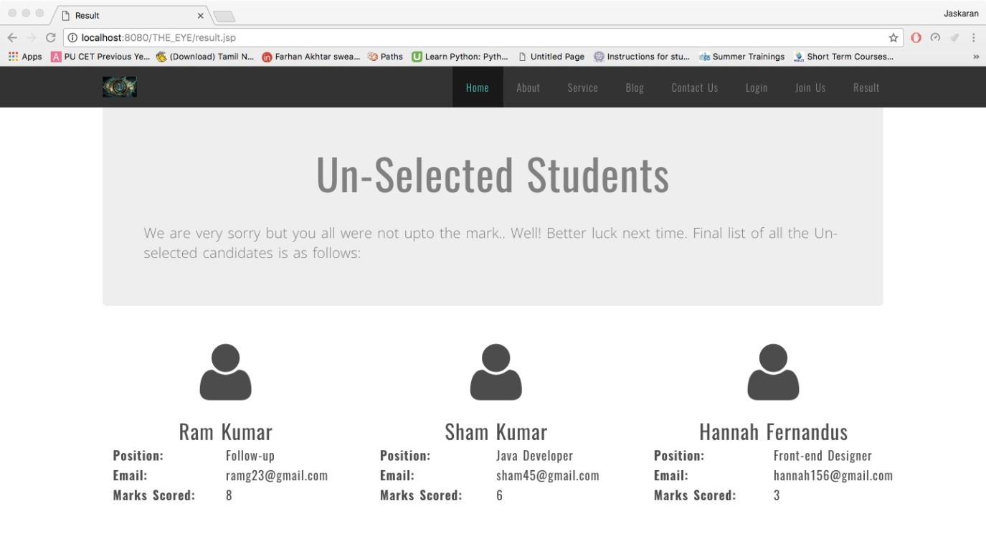

***BIBLIOGRAPHY***

## Websites

Following websites are referring to create this project reports.

* <http://www.google.com>
* <http://www.tutoriaspoint.com>
* <http://www.javatpoint.com>
* <http://www.stackoverflow.com>
* http://www.wikipedia.org
* http://www.quora.com